Set up SDL Library

The project involves the use of an external SDL library to run, and that involves modifying some elements in the project properties within Visual Studio so the game can run properly. While all these steps were already taken in the submitted Visual Studio project, this is made as a backup just in case the project does not run.

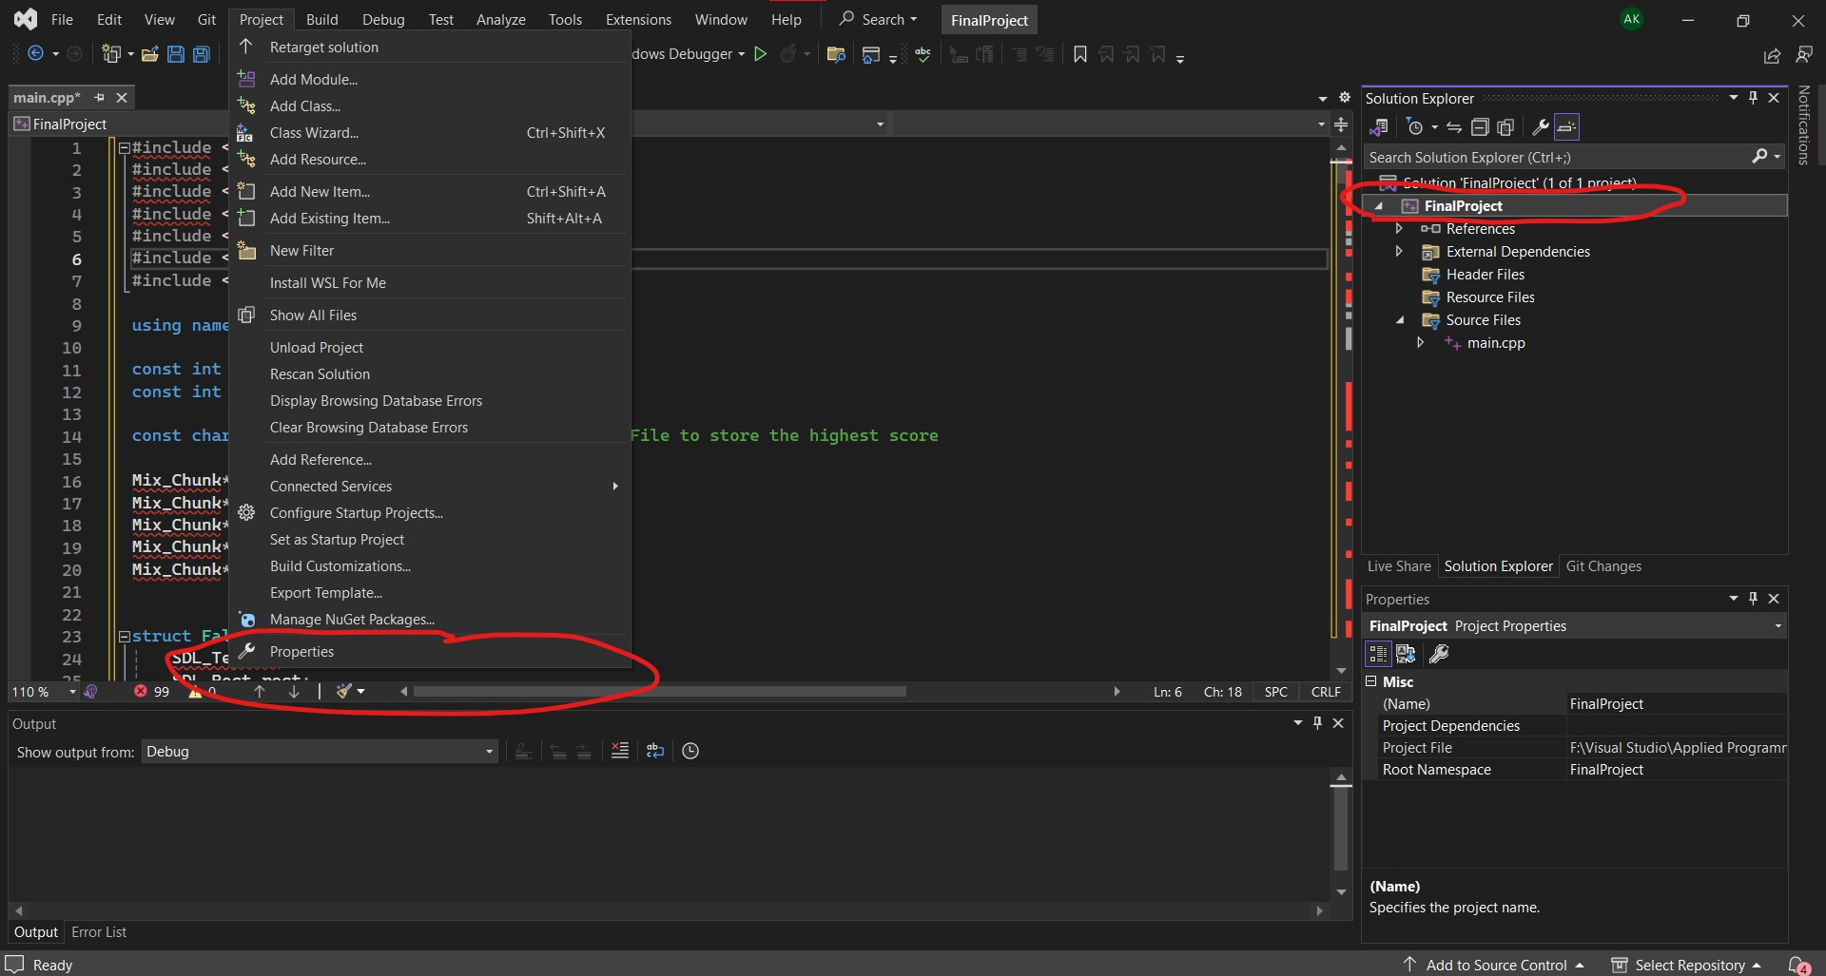
- Making sure that “FinalProject” in the Solution Explorer is highlighted, click on project on top of the screen and select “Properties” or “FinalProject Properties”

- Under Configuration Properties, select “VC++ Directories”.

- Click on “Include Directories”, and select the “edit” that appears for more options. In that screen, click on the folder image and then the “…” button that appears to select the appropriate files
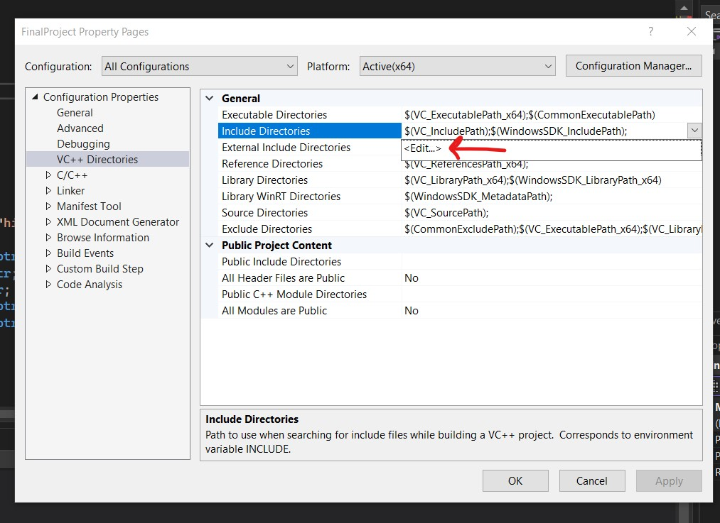

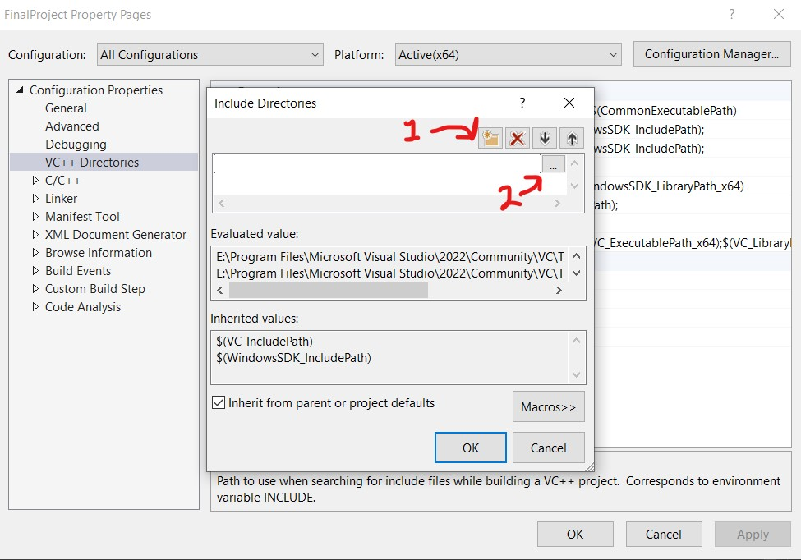

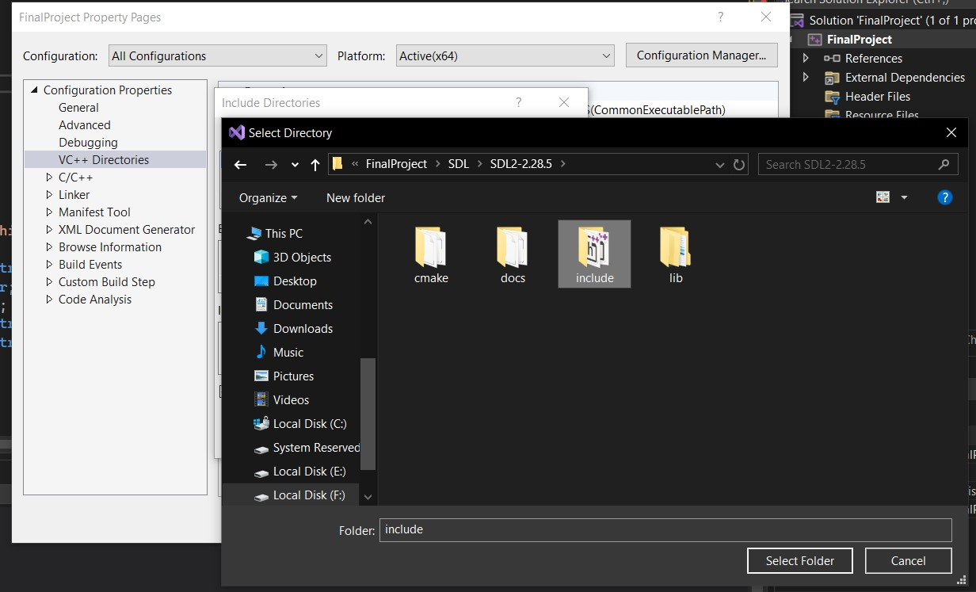
- Select the SDL folder. There are 4 SDL library folders. Starting with “SDL2-2.28.5”, select the “Include” files. Repeat this step for the remaining three folders.
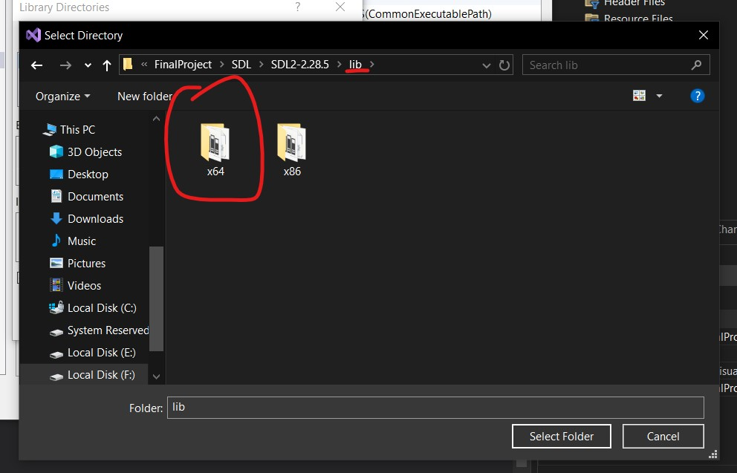
- Select Library Directories in the same “VC++ Directories”, and then edit for more options. Repeat the same step as before by clicking on the folder pic and then the “…”. This time, go to the “lib” folder and then select “x64”. Repeat this step for all 4 SDL library folders

- Under the “Linker” Option, select “Input”. In the Input Screen. Select Additional Dependencies, and then “Edit”.
Type in the following, and press OK:

SDL2.lib
SDL2main.lib
SDL2test.lib
SDL2_image.lib
SDL2_ttf.lib
SDL2_mixer.lib
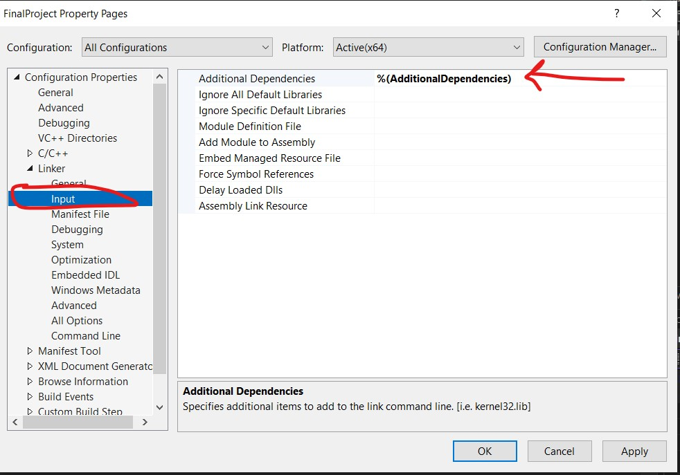

- This final step might not be necessary since it is already done, but it is still better to say.
Under all 4 libraries, open “lib”, and then “x64”, and copy ALL dll files and paste them to the main FinalProject File.

The project should run after following all these steps.

